**ProjectM  
Team 10**

Dajiba Patil, Abhijeet Chavan, Myles Lefkovitz, Daniel  Reeves

[dpatil32@gatech.edu](mailto:dpatil32@gatech.edu), [achavan8@gatech.edu](mailto:achavan8@gatech.edu), [mlefkovitz@gatech.edu](mailto:mlefkovitz@gatech.edu) [danielreeves@gatech.edu](mailto:danielreeves@gatech.edu)   

This project focuses on the task of a user going to a store to shop for items.  Online shopping notwithstanding, the current user experience can be less than ideal for shoppers going into a physical store to shop for items and this project aims to improve that experience for both novice and veteran shoppers alike.

# Introduction

This project expands on the work performed by Dajiba Patil in the Assignment M series. An original interface was designed for traditional in-store shoppers to find goods in stores more easily.

# Needfinding Planning

## User Types

We have identified 3 types of users for this tool:

1. Store customers (regular people who visit stores to purchase goods for themselves)
2. Professional shoppers (Instacart shoppers)
3. Store owners

Store customers and professional shoppers are customers who would use the interface created in the first design iteration for this task.

Store owners are a different type of user with different needs. Buy-in from store owners will be needed for this application to succeed. Store owners will play a part in ensuring that the interface can remain updated with consistent information about store products.

## Needfinding Plan 1 - Surveys for Store Customers

Store customers were the target audience for needfinding in the first interface design iteration. We will use these surveys to ask more targeted questions that will drive the design of the interface.

The goal of this survey will be to better understand shoppers’ current practices when shopping in stores. The questions asked will reveal how frequently they carry their smartphones (key to being able to use an app-based interface), how often they look for new items, how much time they spend looking for those items, how frequently they ask for help, and how helpful they find the help. We will also ask shoppers what they think will help improve their shopping experience.

**Data Inventory Items**

In the first iteration of this interface design, we identified who the users are (shoppers), where they are (in stores), the context of their task (busy focusing on finding their items and navigating the store), their goals (buying the items on their shopping list), and their task (buying items).

We will use the surveys below to identify the remaining data inventory items (the user’s needs and their subtasks).

**Biases**

With surveys, we may encounter a number of potential biases: confirmation bias, observation bias, voluntary response bias, and recall bias all present potential issues.

Confirmation bias poses a risk at the survey review phase. I can limit the impact of confirmation bias by collecting as much empirical data as possible from the respondents and leaving questions open-ended, inviting them to provide information that’s not aligned with my questions. Once in the data-review phase, we will specifically seek out information that contradicts our pre-existing notions.

Observation bias poses a risk at the survey design phase. We may design a survey that aligns too closely with my specific beliefs about shopping. We will limit this impact by scripting the survey as neutrally as possible.

Voluntary response bias poses a risk to our survey, as users more excited about shopping (in either direction) are more likely to respond. We will limit this impact by avoiding showing questions to users until they’ve begun the survey.

Recall bias poses a risk to my survey at the response phase. Respondents may not have shopped recently (or may not have shopped for new items recently). We can limit this impact by inviting respondents to consider their recent previous experience shopping.

**We created the following survey questions (with the summary below):**

The following questions pertain to your shopping experience at grocery stores (Kroger, Publix), wholesale clubs (Costco, Sam’s), department stores (Walmart, Target), and hardware stores (Home Depot, Lowes). Please describe your experiences at these stores.

1. How often do you plan to buy new items that you haven’t purchased before?
2. Always
3. Often
4. Sometimes
5. Rarely
6. Never
7. On average how much time do you spend searching for specific items you’re unable to locate? (in minutes) _________
8. Describe your agreement with the following statement: In general, I am consistently satisfied with my current shopping experience.
9. Strongly Agree
10. Agree
11. Neither
12. Disagree
13. Strongly Disagree
14. Is your preferred in-store shopping method browsing all of the aisles or going straight to the items you need?
15. Browsing all of the aisles
16. Going straight to the necessary items
17. A mixture of both
18. What things would enhance your shopping experience?
19. Shopping List
20. In-Store Navigation/Mapping
21. Electronic Product Locator
22. Other
23. If you selected Other on the previous question, please describe it here  
    ________________________
24. On a scale from 1 to 5, how often do you have your personal smartphone with you while shopping?
25. Always
26. Often
27. Sometimes
28. Rarely
29. Never
30. Do you ever utilize existing shopping cart programs such as Kroger's clicklist?
31. Yes
32. No
33. Do you use shopping services like instacart or store's shopping services?
34. Yes
35. No
36. If you answered Yes to previous question, what is the main reason you use these services
37. Busy schedule
38. Shopping difficulties
39. Other
40. If you answered “Other” to the previous question, please explain:   
     ____________
41. How often do you use shopping lists?
42. Always
43. Often
44. Sometimes
45. Rarely
46. Never
47. If you use a shopping list, approximately what proportion of the time are you the person creating the shopping list for your shopping episode (vs someone else)? (in %) ________
48. Describe your agreement with the following statement: It is helpful to plan the path you will take to collect each item on your shopping list.
49. Strongly Agree
50. Agree
51. Neither
52. Disagree
53. Strongly Disagree
54. How frequently do you seek help to decide on a product when presented with number of options?
55. Always
56. Often
57. Sometimes
58. Rarely
59. Never
60. Describe your agreement with the following statement: When I ask for help locating an item that is on my shopping list, I am very satisfied with the help I receive.
61. Strongly Agree
62. Agree
63. Neither
64. Disagree
65. Strongly Disagree

## Needfinding Plan 2 - Interviews with Professional Shoppers

Professional shoppers are a new target audience that we speculate could find good use from an interface like the one designed in the previous iteration. We’ll conduct interviews with professional shoppers to learn more about the tools available to them, their inputs, and their needs.

**Data Inventory Items**

With this new user group, we will need to identify each of the data inventory items. We suspect we have an understanding of who the users are (professional shoppers), where they are (in stores), the context of their task (busy focusing on finding their items and navigating the store), their goals (buying the items on their users’ shopping list), and their task (buying items).

We will use the interview below to confirm our understanding and identify the remaining data inventory items (the user’s needs and their subtasks).

**Biases**

With interviews, we may encounter a number of potential biases: confirmation bias, observation bias, and social desirability bias all present potential issues.

We can limit the impact of confirmation bias by collecting as much empirical data as possible from the respondents and leaving questions open-ended, inviting them to provide information that’s not aligned with our understanding. Once in the data-review phase, our team will specifically seek out information that contradicts our pre-existing notions.

Observation bias poses a risk at the script design phase. We may design an action or question that aligns too closely with our specific beliefs about the experiences of professional shopper. We will limit this impact by scripting the questions as neutrally as possible.

Social desirability bias poses a risk during the interview.  We will limit this impact by conducting interviews over the phone (not revealing the interviewer’s face) and making sure to ask questions exactly as scripted, with no sounds guiding the user to a specific answer.

**Planned interview script:**

Thank you for taking the time to meet with me today. I’d like to discuss your role as a professional shopper.

1. Can you briefly walk through a recent typical professional shopping experience (maybe walk through a day or a shift)?
2. When shopping for customers instead of shopping for yourself, what differs about the experience?
3. What is your main focus when shopping for customers?
4. How many customers are you typically shopping for at a time?
5. What tools does your shopping company (Instacart) provide you with?
6. Is there anything you can think of that could improve your shopping experience?
7. What do you do if a particular item is not available in store?
8. How frequently do you need to ask for help in locating an item?

## Needfinding Plan 3 - Interviews with Store Owners

Store owners are an important user whose needs were not evaluated in the first iteration of the design of this interface.

Store Managers are important component of this interface. And as such, it's very important to take their consent in terms sharing some key business-related information such as store locations, store size, store layout and product placement in aisle and bins. This information is crucial at times as it might impact the business strategy in terms of sales, forecasts and competition. Furthermore, protecting the above information from its competitor also forms one of the requirement for this interface. To unfold the above mystery, we are planning to interview the Store Managers as part of our need finding exercise. Secondly, we would also interview the shoppers to understand their perspective. As noted earlier we are still in process of finalizing our plan of approach but here are draft questions that we would like to ask the Store Managers

**Data Inventory Items**

With this new user group, we will need to identify each of the data inventory items. We suspect we have an understanding of who the users are (store owners/managers), where they are (in stores), the context of their task (creating a dynamic environment that best supports their customers), their goals (enrich the experience of their customers in order to maximize profit)..

As a secondary user for our tool, we understand that these users have tasks, but we assume that their tasks are unrelated to the tasks of the customers.

We will use the interview below to confirm our understanding and identify the remaining data inventory items (the user’s needs and their subtasks).

**Biases**

With interviews, we may encounter a number of potential biases: confirmation bias, observation bias, and social desirability bias all present potential issues.

We can limit the impact of confirmation bias by collecting as much empirical data as possible from the respondents and leaving questions open-ended, inviting them to provide information that’s not aligned with our understanding. Once in the data-review phase, our team will specifically seek out information that contradicts our pre-existing notions.

Observation bias poses a risk at the script design phase. We may design an action or question that aligns too closely with our specific beliefs about the experiences of store owners. We will limit this impact by scripting the questions as neutrally as possible.

Social desirability bias poses a risk during the interview.  We will limit this impact by conducting interviews over the phone (not revealing the interviewer’s face) and making sure to ask questions exactly as scripted, with no sounds guiding the user to a specific answer.

**Planned interview script:**

Thank you for taking the time to meet with me today. I’d like to discuss your role as a store owner (or manager).

1. Customers often visit your store looking for items they haven’t purchased before, either as first time customers or as repeat customers buying a new item for the first time. As a store owner, do you think your customers have any issues finding products within your stores?
2. What steps can customers take to seek help finding the items on their shopping lists?
3. How many dedicated staff do you have to help customers find items?
4. How many hours do you estimate your staff dedicates to helping customers find the items they’re shopping for?
5. How interested are you in collaborating with third parties to help your customers find items within your store?
6. Would you be willing to share the layout of your store and each item’s bay location with third parties?

# Needfinding Execution

## Needfinding Plan 1 - Surveys for Store Customers

**Survey Results and Observations**

In total, our team received fifty responses to the sixteen survey questions above.  A few of the **raw results** gleaned from this data include the following observations:

* When purchasing new items, most respondents (31/48) claim they spend 10 minutes or more searching for these items within stores.
* The average shopper surveyed was satisfied with their current shopping experience. 5/50 shoppers were dissatisfied, 15/50 were neutral in satisfaction, 30/50 either agreed or strongly agreed that they were satisfied.
* Many shoppers thought that an electronic product locator (36/50), mapping tools (26/50), or a shopping list (24/50) would benefit their shopping experiences.
* 44/50 respondents claimed they had a smartphone with while they shop ‘very frequently’.
* Most respondents (44/50) do **not** utilize existing shopping cart programs such as Kroger’s clicklist, nor do they (42/50) utilize existing shopping cart services such as Instacart.
* Of the users that have utilized these types of services, 6/8 of the respondents used them due to a busy schedule.
* Shopping lists were utilized by 33/50 of the respondents ‘frequently’ or ‘very frequently’.
* Shoppers create their own list an average 55% percent of the time (with others creating a list for them 45% of the time).
* 36/50 users agree or strongly agree that planning the path to collect each item on list is helpful while shopping.
* 36/50 users agree or strongly agree that they are satisfied with the existing help they receive in stores while on their shopping trips.

**Survey Results Analysis**

The **takeaway** from this survey is that many of the respondents spent more time searching for an item they did not know the location of while on their shopping trip.  The results of the shopping experience question for these users shows there is possible improvement in this area, as most noted an average experience when shopping.  Improvements in this area such as the store shopping list and electronic product locator showed considerable interest from those surveyed. As most of the respondents carry their personal smartphone with them while shopping, the possibility to improve the experience with this task utilizing a smartphone is one opportunity that is presented.

One interesting fact that came out of this survey is that most of the respondents have not utilized an existing shopping cart service such as Kroger’s Clicklist or Instacart.  One user noted that this was due to lack of promotions of these services by the stores themselves, poor user guidance of these services, and general awareness of these existing programs was low.  The small number of users that did utilize these services, however, utilized them due to a busy schedule.

Overall, it appears that the results of this survey show that there is an opportunity to improve the experience of shopping for users through applications of technology in the areas where it is most needed.  The users’ goals in the data inventory can be met through this application and the subtasks discovered by the surveys (path taken while shopping, item aisle searching, etc) are disclosed and improved where applicable.

## Needfinding Plan 2 - Interviews with Professional Shoppers

Please refer to appendix D and F for interview details will professional shoppers from Instacart and Shipt.

# Needfinding Plan 3 - Interviews with Store Owners

So far, our team members were able to interview 2 store owners one from Bottle King, a wine store and another from Lowes, a hardware retailer. Following were the raw results from our interaction with the above store owners.

* Both the store owners confirmed that the customers looking for items they have not shopped earlier and the first-time customers, both have problems finding the items. However, these customers can find help from the store personnel on the floor, ask for help at the front desk and or find item categories displayed via sign boards to trace the items that they are looking for.
* Bottle King confirmed that they have dedicated staff anywhere between 2 to 12 personnel on the floor all the time. Whereas, Lowes confirmed that their store has a dedicated staff of around 20 personnel on the floor who can help customer’s find the items.
* Both the store managers confirmed that the store personnel on the floor, as mentioned above, are available to help customer’s during the entire store hours e.g. Lowes 6 am to 10 pm during weekdays.
* Both the above store owners were not in favor of collaborating with the third parties to help customers find items and share the store layout and bay location information due to the corporate policies.

Please refer to appendices A through F for more interview details.

## Design Alternatives:

Individual brainstorming session was conducted where the project team members were asked to pen different ideas based on the need finding exercises conducted earlier. As a result, following ideas were generated.

* Grocery Store Pathing App on Smartphone
* Turn by turn directions in the store
* Stores with only professional shoppers - submit a list and get a bag of groceries when you walk in/delivered to your car (this exists at Target/Publix/Walmart)
* Server-hosted shopping list with multiple users
* Focus more on shopping list creation help
  + auditory
  + scan the barcode
  + import from old list
  + analytics based on old shopping pattern
  + Web api to get the location
* Microsoft Surface to store the store layout and spit the hard copy of map in combination with Cellphone map of the store
* Combination of Intel Clarity Glasses for interface and API for the store owners to store the store location and product details
* Combination of Cellphone and API for the store owners to store the store location and product details
* Core problem: User needs an efficient/quick way to shop on any given shopping trip.
* What incentives could people get to use this type of program?  Motivations?
* Aim for simple usage of app or invisible interfaces.
* Smartphone app with incentives for using
* Monetary; coupons; other incentives?
* App runs while user is shopping, so little interaction is required.  Maps out store while running.
* Requires no other hardware than phone.
* Physical units inside the store
* Must deal with hardware costs and having to pay store owners rent for floor space to house the units themselves.
* Theft and security issues to resolve.
* Would get users that don’t have a smartphone, but would these users even use this device in the first place?

Post the individual braining storming session we have planned to conduct a Group brainstorming session, where each project team member will be allowed to present the ideas of their choice. This session will follow all the rules of engagement of group brainstorming such as going through individual ideas, set clear rules of communication and expectations etc. The session planned will encourage the participants by giving them a chance to express themselves. During this time the ideas will not be questioned or evaluated. Post this session the ideas will be selected for prototypes.

# References

# Appendices

## Appendix A: Interview with Bottle King Store Owner

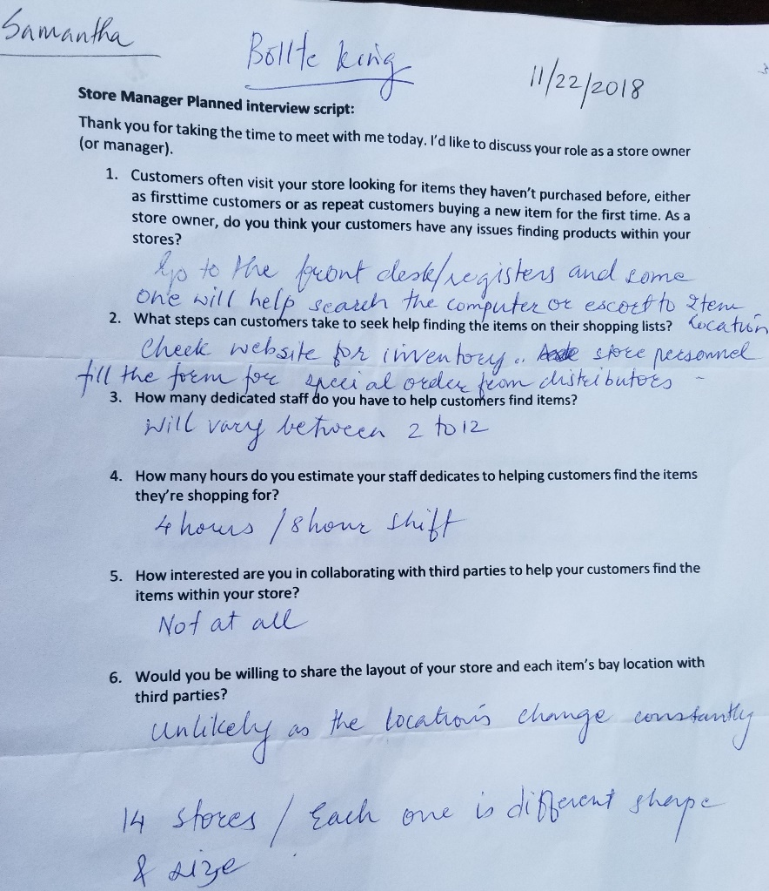

## Appendix B: Interview with Lowes Store Owner

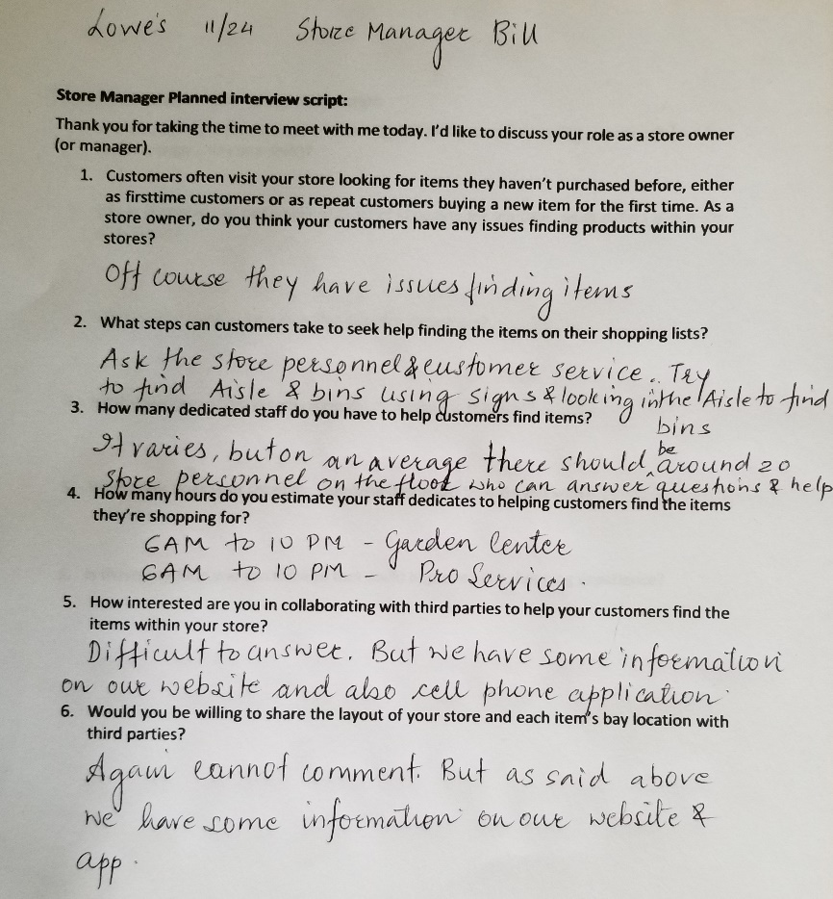

## Appendix C: Interview with Lowes Store Owner

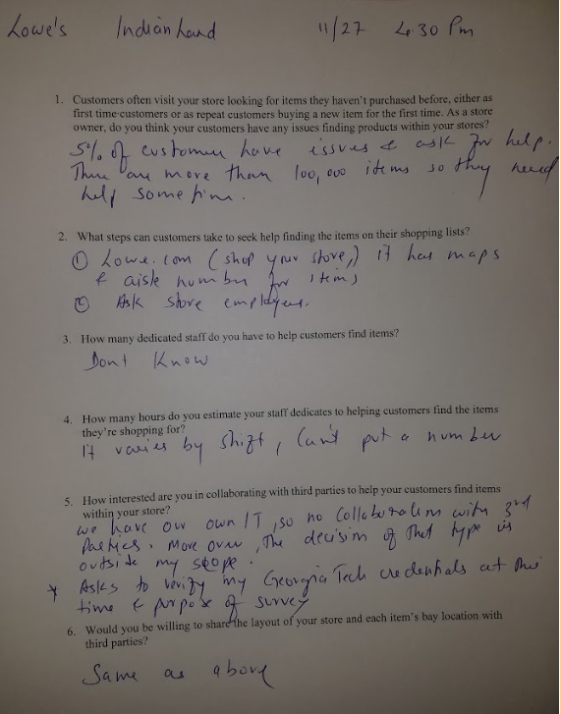

## Appendix D: Interview with Instacart shopper inside Publix

Thank you for taking the time to meet with me today. I’d like to discuss your role as a professional shopper.

1. Can you briefly walk through a recent typical professional shopping experience (maybe walk through a day or a shift)?

First, grab a cart and the customer’s bag (each customer is given a brown bag with their name and a barcode). The app lists the customer’s shopping list in order of pickup location within the store. Traverse the store and pick up the relevant items in list order. Once the bag has been filled, place it on the filled bags shelf either within or outside of the freezer. A separate delivery driver will pick up the bags for delivery.

1. When shopping for customers instead of shopping for yourself, what differs about the experience?

No difference - as an experienced shopper I am able to locate basically any item in the store.

1. What is your main focus when shopping for customers?

Keep refunds down by offering replacements. Keep speed up (create shopping bags as quickly as possible).

1. How many customers are you typically shopping for at a time?

1 or two customers at a time.

1. What tools does your shopping company (Instacart) provide you with?

The Instacart app shows shopping items in order along with customer notes and allows the shopper to communicate with the customer via phone or text

1. Is there anything you can think of that could improve your shopping experience?

Shopping without other customers in the store!   
Sometimes the app doesn’t list locations of items correctly and you’ll need to manually locate an item.

1. What do you do if a particular item is not available in store?

Check the back of the store (the warehouse). If the item is truly out of stock, offer to find a replacement item for customers.

1. How frequently do you need to ask for help in locating an item?

Never. With experience we know where all items are.

## Appendix E: Interview with Anthon, a manager at my local Publix

Thank you for taking the time to meet with me today. I’d like to discuss your role as a store owner (or manager).

1. Customers often visit your store looking for items they haven’t purchased before, either as first time customers or as repeat customers buying a new item for the first time. As a store owner, do you think your customers have any issues finding products within your stores?

Yes, because stores are often differently laid out

1. What steps can customers take to seek help finding the items on their shopping lists?

There are always associates nearby that customers can ask for assistance.

1. How many dedicated staff do you have to help customers find items?

Over 20 at any given time

1. How many hours do you estimate your staff dedicates to helping customers find the items they’re shopping for?

3 hours throughout the day

1. How interested are you in collaborating with third parties to help your customers find items within your store?

Already partnered with instacart and location apps - check the Publix website

1. Would you be willing to share the layout of your store and each item’s bay location with third parties?

Not sure if we do so currently, but we have a team focused on this data internally. Maybe Publix corporate could help answer this question.

## Appendix F: Interview with Shipt representative at Publix

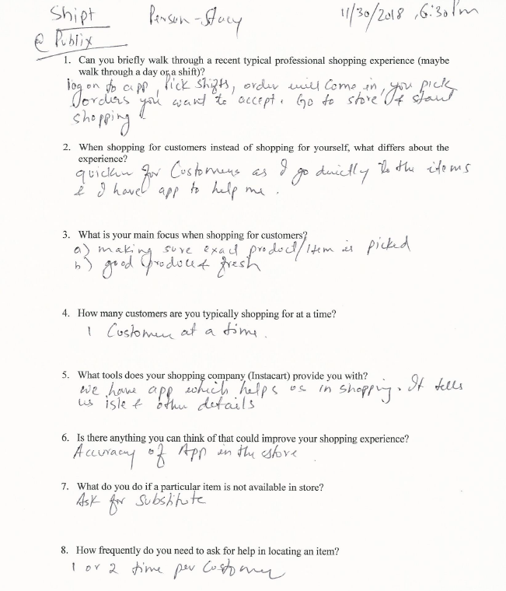

## Appendix G: Screen displaying the shortest path to pickup list of items

